Manmeet Singh
CSC 110
Professor Kumar

Part 1
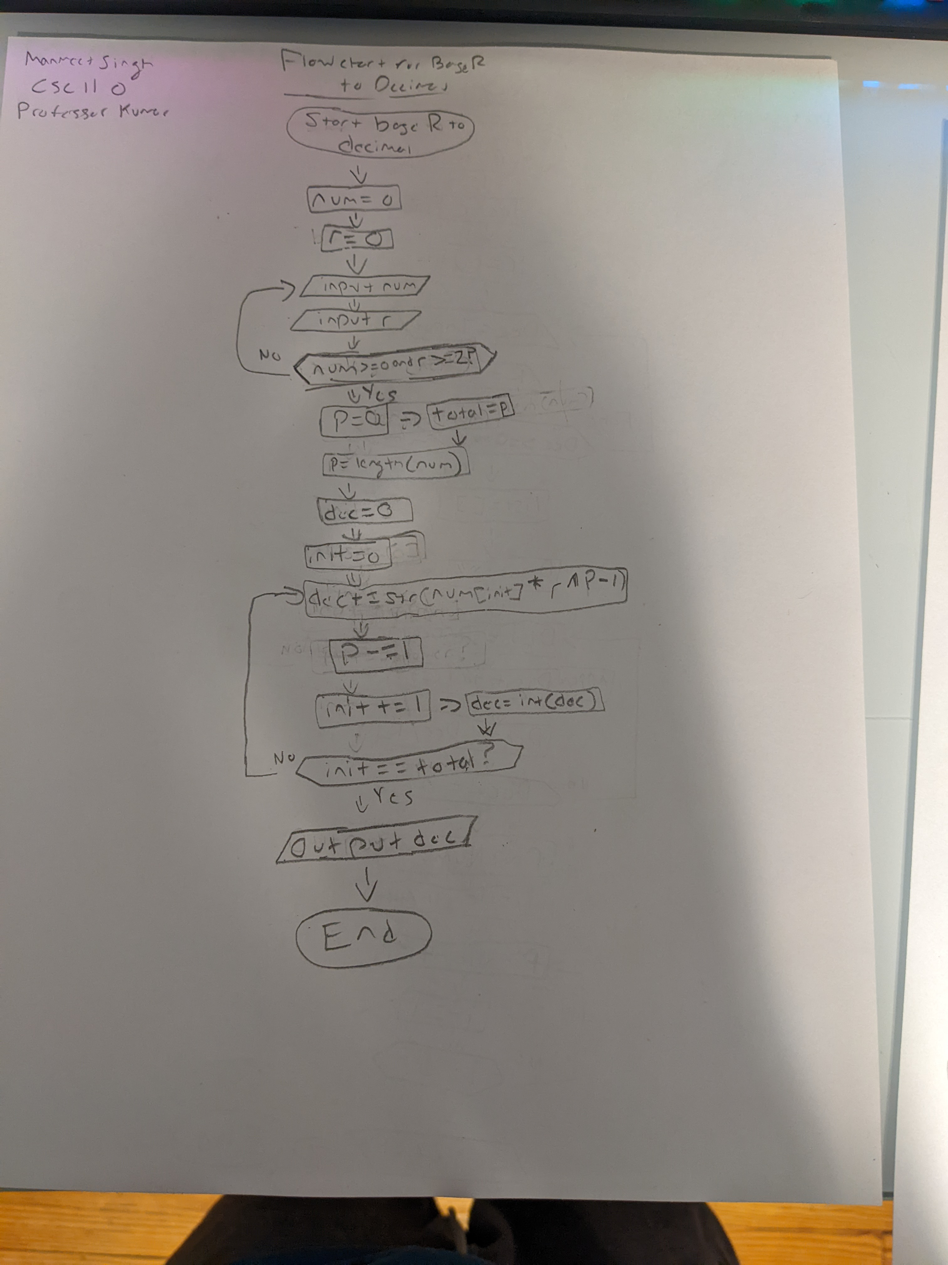
A and B.
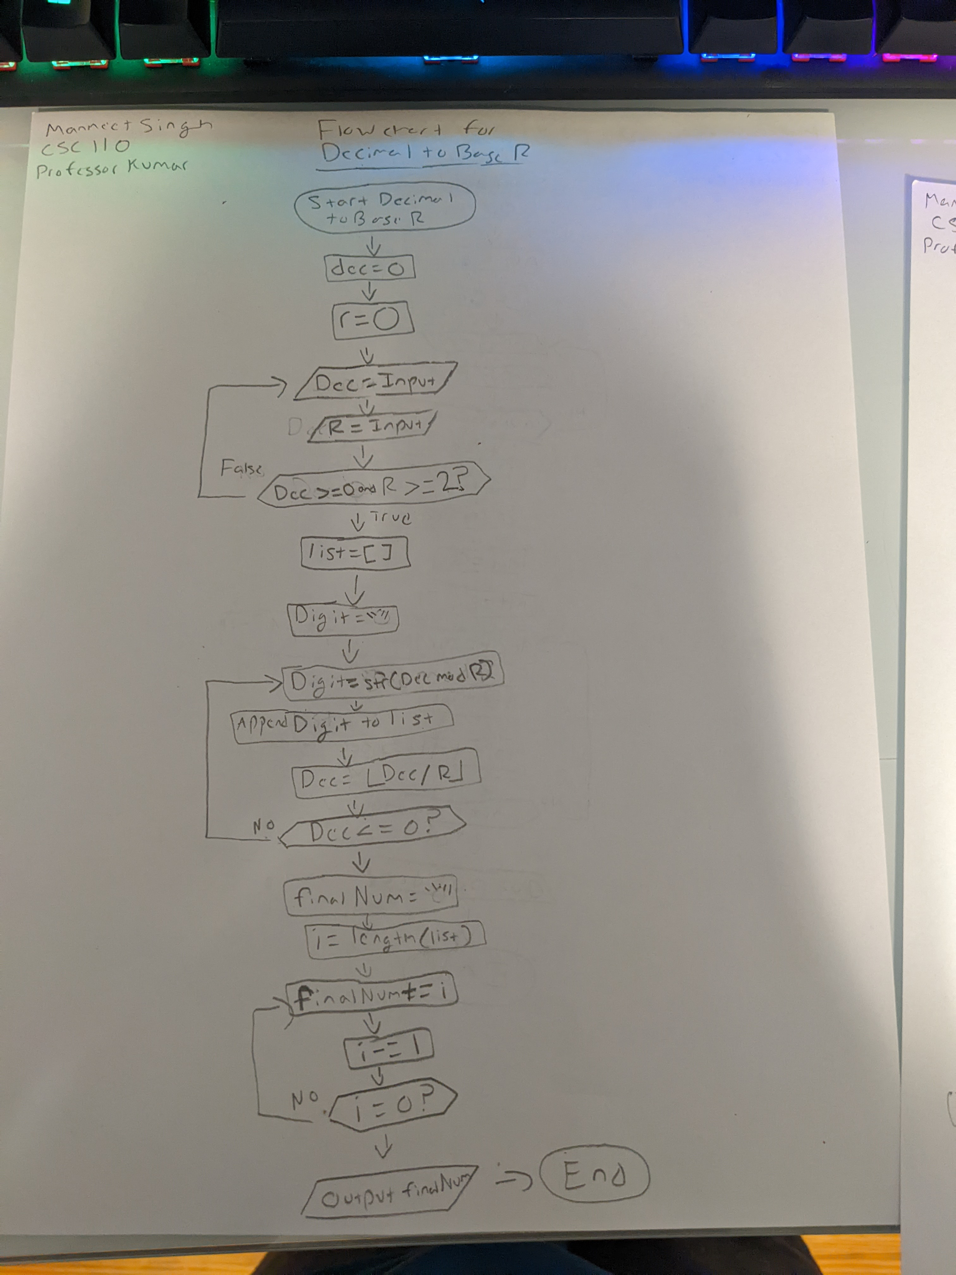

C. 9’s Complement: 1237 – 237 → 999 - 237 = 762 → 1237 + 762 = 1999 → (Add 1) → 1000

1237 to binary → 0000010011010101 (Using 2 Bytes (16 Bits))
2 | 1237 | 1
2 | 618 | 0
2 | 309 | 1
2 | 154 | 0
2 | 77 | 1
2 | 38 | 0
2 | 19 | 1
2 | 9 | 1
2 | 4 | 0
2 | 2 | 0
2 | 1 | 1
2 | 0

237 to binary → 0000000011101101 (Using 2 Bytes (16 Bits))
2 | 237 | 1
2 | 118 | 0
2 | 59 | 1
2 | 29 | 1
2 | 14 | 0
2 | 7 | 1
2 | 3 | 1
2 | 1 | 1
2 | 0
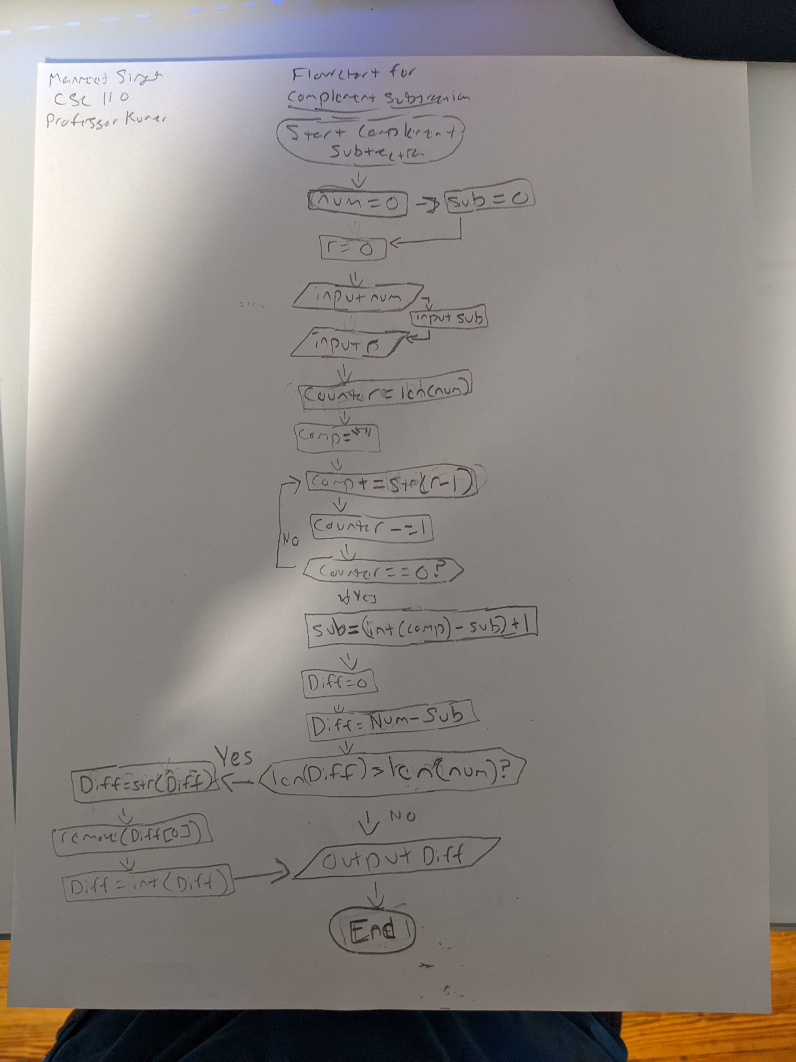
One’s Complement: 0000000011101101 → 1111111100010010
0000010011010101 + 1111111100010010 = 0000001111100111 + 1 = 0000001111101000

Two’s Complement: 0000000011101101 → 1111111100010011
0000010011010101 + 1111111100010011 = 0000001111101000

